**Company-** QuickData

**Category**- Informative

**Main Keyword**: How to Easily Delete All Gmail Emails after Backup

**Keywords:**

how to easily delete emails in gmail, how to download all gmail emails and attachments, can i export all my gmail emails, is there a way to mass delete emails on gmail, gmail mail backup download, gmail backup emails to hard drive, gmail backup email folder, how to take backup of all emails from gmail

**How To Easily Delete All Gmail Emails After Backup**

Nowadays, many users decide to move from Gmail to another email service and need to delete all emails before making the change. It is common to see users who want to empty their mailbox due to various reasons. But, users also want to keep a backup of all their Gmail data, on the hard disk. Because sometimes they need the important Contacts, emails, Calendar details for use later on. In this blog, we are going to explain how to easily delete all Gmail emails after backup.

**Reasons for Complete Email Backup & Deletion**

As seen, users want to delete all Gmail data because of the various following reasons:

* Many users are increasingly looking for desktop-based email clients to have their data with them, even for offline use.
* In the past, Google has suffered user data loss and therefore, some users feel safe having a backup of their important data on their hard disk.
* Some users fear hacking of personal data saved on the cloud.
* Shifting from one email client to another, and need to keep a backup of old data.
* Contacts, Calendar events, Bookmarks and search data, that could come handy in the future.

**Method to Backup and Delete All Gmail Emails**

There is no one way to have a Gmail backup email folder and simultaneously delete them. Therefore, it will have to be done in two phases. First are the steps on how to take backup of all emails from Gmail:

**Step -1: Backup all Gmail Emails**

A backup of Gmail data can be obtained using Google Takeout in your browser. The steps are as follows:

1. Sign in to the Gmail account you want to backup.
2. In a new tab, open Google Takeout.

**Note:** Google Takeout can only be accessed using the URL https://takeout.google.com/settings/takeout.

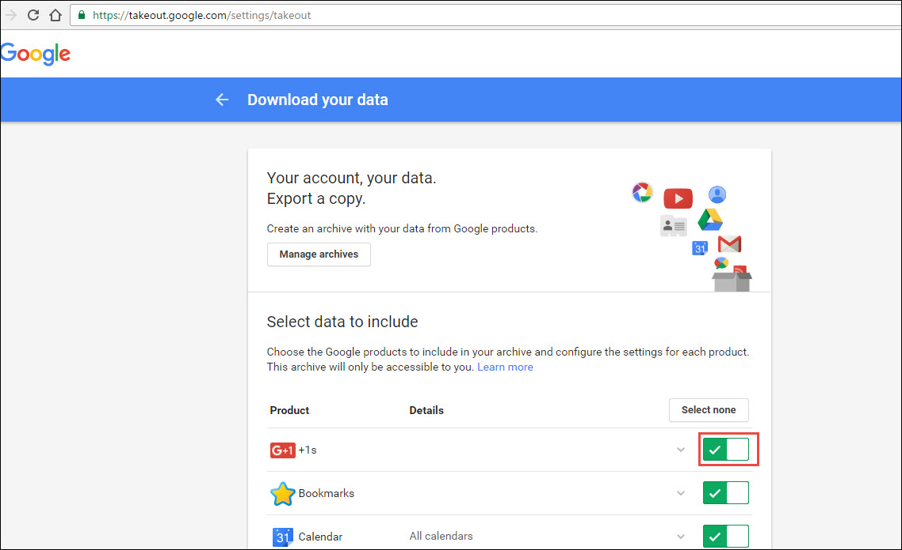

1. The ***Download your data*** page will open. You can opt to download all Gmail data, or deselect ones you do not need an archive of. Click ***Next***.
2. Now, you can choose the format of the archive (.zip, .tgz, .tbz). And select the method of delivery from 4 options namely ***Download Link via email, Add to Drive, Add to Dropbox and Add to OneDrive.*** Click ***Create Archive*** to complete.

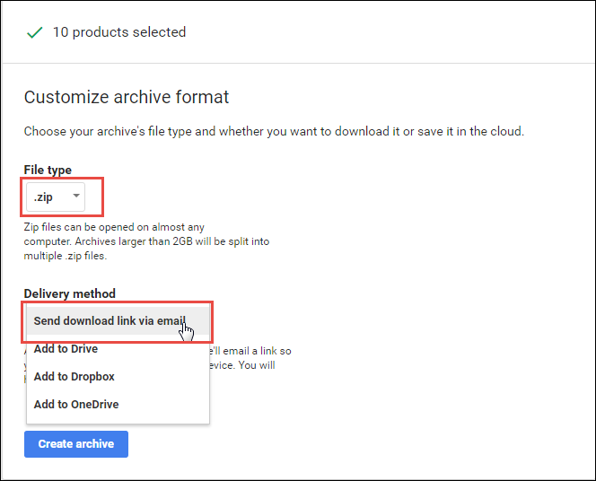

1. A new page with the status of currently processing archive will open. You can ***Create Another Archive*** from this page.

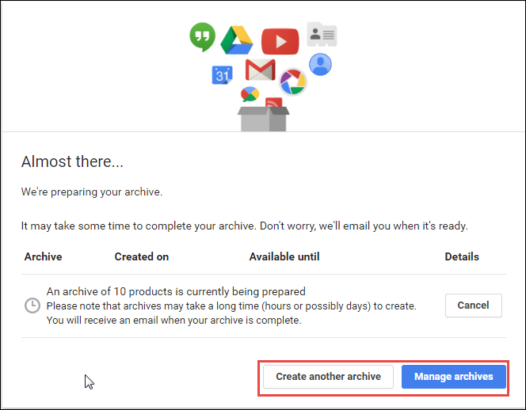

1. The ***Manage Archives*** button can be used to view the archive details, date of creation and a Download button. Click ***Download*** for your Gmail mail backup download.

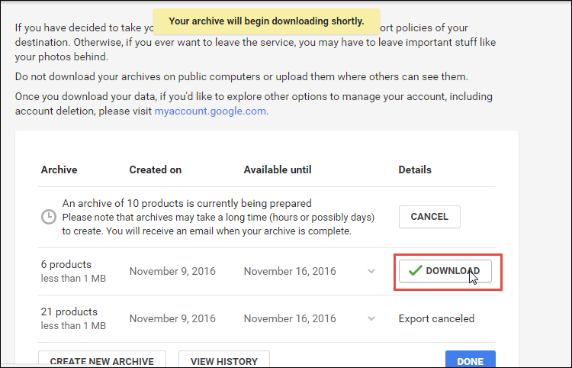

All the Gmail messages are now successfully downloaded in MBOX format, and calendars as ICAL. Searches can be viewed as a JSON file through Notepad.

**Step-2: Delete Emails in Bulk**

Deletion of all emails is never possible with Gmail. At a given time, you can delete only by labels or folders by selecting the displayed mails. The following steps illustrate how to easily delete emails in Gmail:

1. Deleting from Inbox: Open *Inbox* and select all mails by clicking the small box on the top left and choosing ***All***. Click the ***Bin*** button to delete all 50 mails on the screen. Repeat this process until the whole inbox is empty.
2. Delete Mails with a particular Label: Go to ***Labels*** on the left pane, and click on the desired label. Select all and ***Bin*** recursively until all mails are deleted.

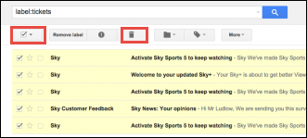

1. Delete all Unread Mail: In the Gmail search bar type ‘***Label: unread***’ and click ***Enter***. A list of all Unread mail is displayed. Again click the checkbox to select All mail, and click the ***Trash/Bin*** button from the top ribbon. The same method is applicable for read mail if you type and enter ***‘Label:read*’** from the Search box.
2. Delete using Search: Deletion of all emails appearing with a particular keyword is also one way. ***Type keyword in the Search box>>Enter***. Select all mail and bin it.

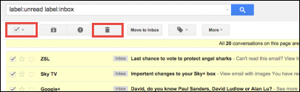

One by one, the mailbox starts emptying. Continue to do this deletion of 50 emails each to delete everything.

**Note:** You can also configure your email address with a desktop client like MS Outlook or Mozilla Thunderbird for a backup of Gmail data. But you will have to occasionally run Outlook to sync the data from Gmail. However, the moment you delete all mails from Gmail, all the emails will be gone the next time Outlook is run.

**Limitations of the Manual Method**

The shortcomings of the manual method can be listed as:

* Time-consuming as we have to manually select and delete emails. The same steps have to be performed repeatedly.
* If there is no internet connectivity, any backup or deletion process cannot be accomplished.
* The Gmail data download offers only a direct download link or cloud-based saving options. If the data is still online, it would be inaccessible in case of cloud mishap.
* The Gmail backup creates files in MBOX format, which is not perfect for every user.
* The Spam, Trash folders are not included in the backup. In addition, Google Play Music is excluded from the backup. These could be important for certain users.

**Alternative Way to Delete Gmail Emails after Backup**

To overcome the challenges faced with the manual method, users can opt for a third party utility Gmail backup tool. Here are some reasons to prefer the automated method:

1. You can back up the data and delete all emails from Gmail in one attempt with the folder structure intact.
2. You can also choose to save your backup file in the format of your liking (.pst, .mbox, .eml, .msg)

**Conclusion**

In this world of cloud, all users realize that it is crucial to have a backup of the Gmail data on their hard drive. The reason could be an inadvertent loss of data, internet unavailability, or fear of hacking. The manual procedure of how to easily delete all Gmail emails after backup was described in this blog. However, a faster, safer alternative is the Gmail backup tool. Users can opt for the method more favorable to their needs. Please leave a comment if you still have a query while performing the Gmail backup and deletion of all emails.